**EXPERIMENT - 2**

**ER DIAGRAM FOR SAILOR BOAT DATABASE**

**Aim:**

Draw an ER diagram of sailors database.

**Components of ER diagram**

**Entity** – An entity is an object that exists in database administration.

**Attribute** – In DBMS an attribute refers to a database component, such as table.

**Primary key** – A primary key is a specific choice of a minimal set of attributes that uniquely specify a tuple in a relation.

**Foreign key** – A foreign key is a set of attributes in a table that refers to the primary key of another table.

**Composite attribute** – It is an attribute where the values of that attribute can be further subdivided into meaningful subparts.

**Derived attribute** – These are the attributes that do not exist in physical database, but their values are derived from other attributes present in the database.

**Relationship** – A relation as originally defined by E.F. codd. Is a situation that exists between two relational database tables.

**Ternary** – A ternary relationship is an association among three entities.

**Many to many** – refers to a relationship between tables in a database when a parent row in one table contains several child rows in second table, and vice versa….

**ER DIAGRAM**

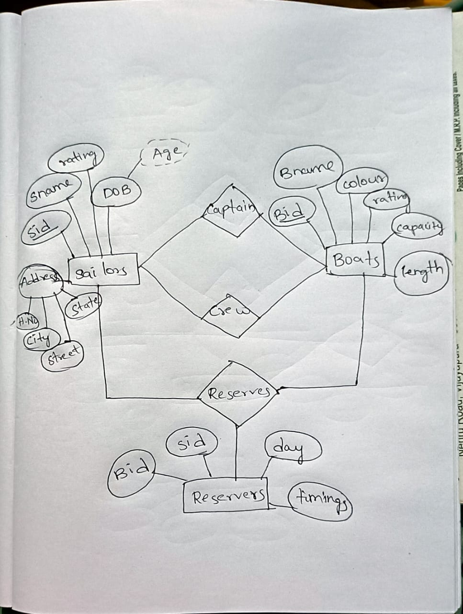

**ER DIAGRAM**

captain

Reserves

crew

RESERVERS

BOATS

SAILORS